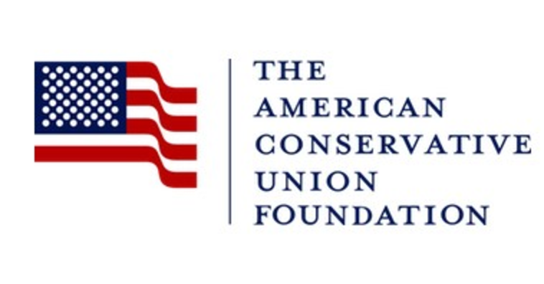
Center for Criminal
Justice Reform

- For immediate release-

CONTACT: David Safavian
Deputy Director
Center for Criminal Justice Reform
202.347.9388

Washington, DC, March 30, 2018 – Yesterday State Senator Julie Raque Adams (ACU rating: 90%) made history as being the first to have introduced a ‘Dignity’ bill specifically tailored to meet the needs of incarcerated women. The American Conservative Union Foundation (“ACUF”) applauds these efforts aimed at restoring human dignity for each woman incarcerated throughout the state of Kentucky.

The Kentucky legislature became the first state in the country to pass a “Dignity Bill,” a piece of legislation with a unanimous 88-0 vote in the House. It is expected to be signed into law by none other than an advocate and leader in criminal justice reform movement, Kentucky Governor Matt Bevin.

Across the nation, women are the fastest growing segment of the prison population and face specific and difficult challenges during incarceration. In Kentucky alone last year, the male incarcerated population grew by 5% while the female population spiked by almost 14%, putting women in the second highest incarceration spot in the state. In addition, one in four women entering Kentucky’s justice system are either pregnant or mothers to children under the age of one. Senate Bill 133 will start to turn the tides on these statistics with banning the practice of shackling women while giving birth, expanding treatment programs for those struggling with addiction, and improving health and hygiene services for all incarcerated women.

Pat Nolan, the Director of ACUF’s Center for Criminal Justice Reform, explained: “As one of Kentucky’s most reliably conservative legislators (with a 90% lifetime ACU rating), it is no coincidence that Sen. Julie Raque Adams was the author of this important bill,” explained Nolan. “The shackling of pregnant women is barbaric, pure and simple, and Senate Bill 133 ends it in Kentucky. But just as important, Sen. Raque Adams’ legislation will help strengthen families and ensure incarcerated women are treated with dignity. I cannot imagine legislation more conservative than that.”
While ACUF works with a number of organizations on ensuring women have the proper treatment and care while incarcerated, our panelists at CPAC this past year helped us voice this issue loudly. Executive Director at Justice Action Network and a native to Kentucky, Holly Harris spoke about

her own state, and the difficulties she learned women go through daily in Kentucky’s jails and prisons. A human rights attorney and cofounder of cut50 with Van Jones who works with former women incarcerated daily spoke on the discrepancies and differences between the males and females in prison. And Kate Trammel from Prison Fellowship who works closely in different states spoke about the human dignity aspect. ACUF is proud to work with many organizations, right and left, working together to ensure each woman in prison, no matter what she’s done, has the basic dignity and respect we all strive for in our lives.

Director Pat Nolan hits the nail on the head when he frequently says, “Each prisoner is a child of God, created in His image, and should never be treated in a way that degrades them.”

For more information on the ACUF Center for Criminal Justice Reform, please go to justice.acu.foundation or call 202.347.9388.

###

